Subject: Programming with Java
ASSIGNMENT No :2
TITLE :Develop a Java application demonstrating the use of default, parameterized, and copy constructors for object initialization and data management.
Assignment 2: Methods and Static Members

Problem Statement
Develop a Java application demonstrating the use of default, parameterized, and copy constructors for object initialization and data management.

Learning Objectives

To understand and implement default, parameterized, and copy constructors for object initialization.

Theory
Constructors are special member functions that are automatically invoked when an object is created. Java supports default constructors provided by the compiler, parameterized constructors for initializing objects with user-defined values, and copy constructors (implemented manually) for creating duplicate objects. Constructors improve code readability and simplify object initialization while supporting object-oriented programming principles.

Outcome Conclusion

Exercise
- Create a Student class using default and parameterized constructors to initialize student name and roll number.
Input:
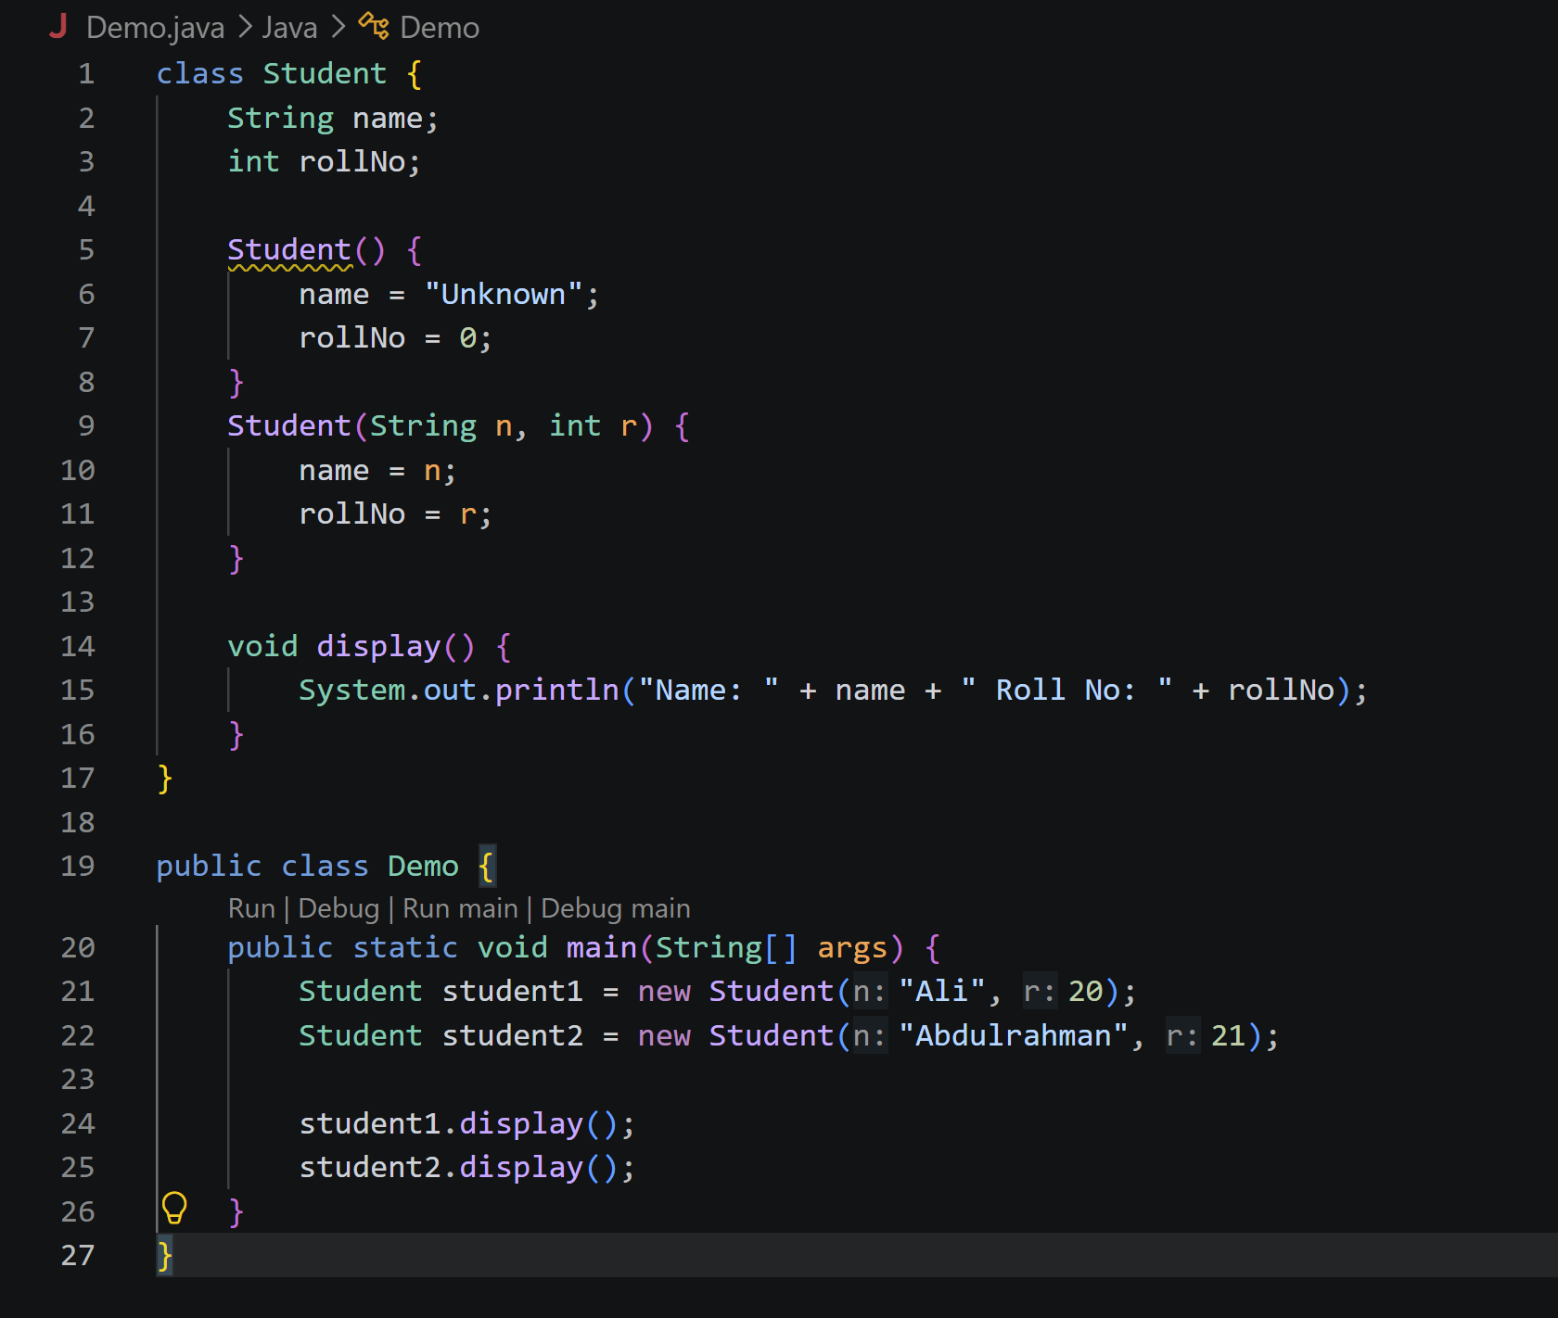
Output:
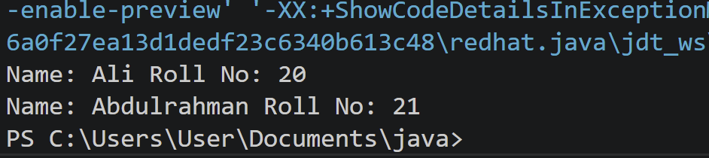
- Develop a Mobile Phone Inventory System using different constructors to initialize mobile details and create duplicate object records.

Input:

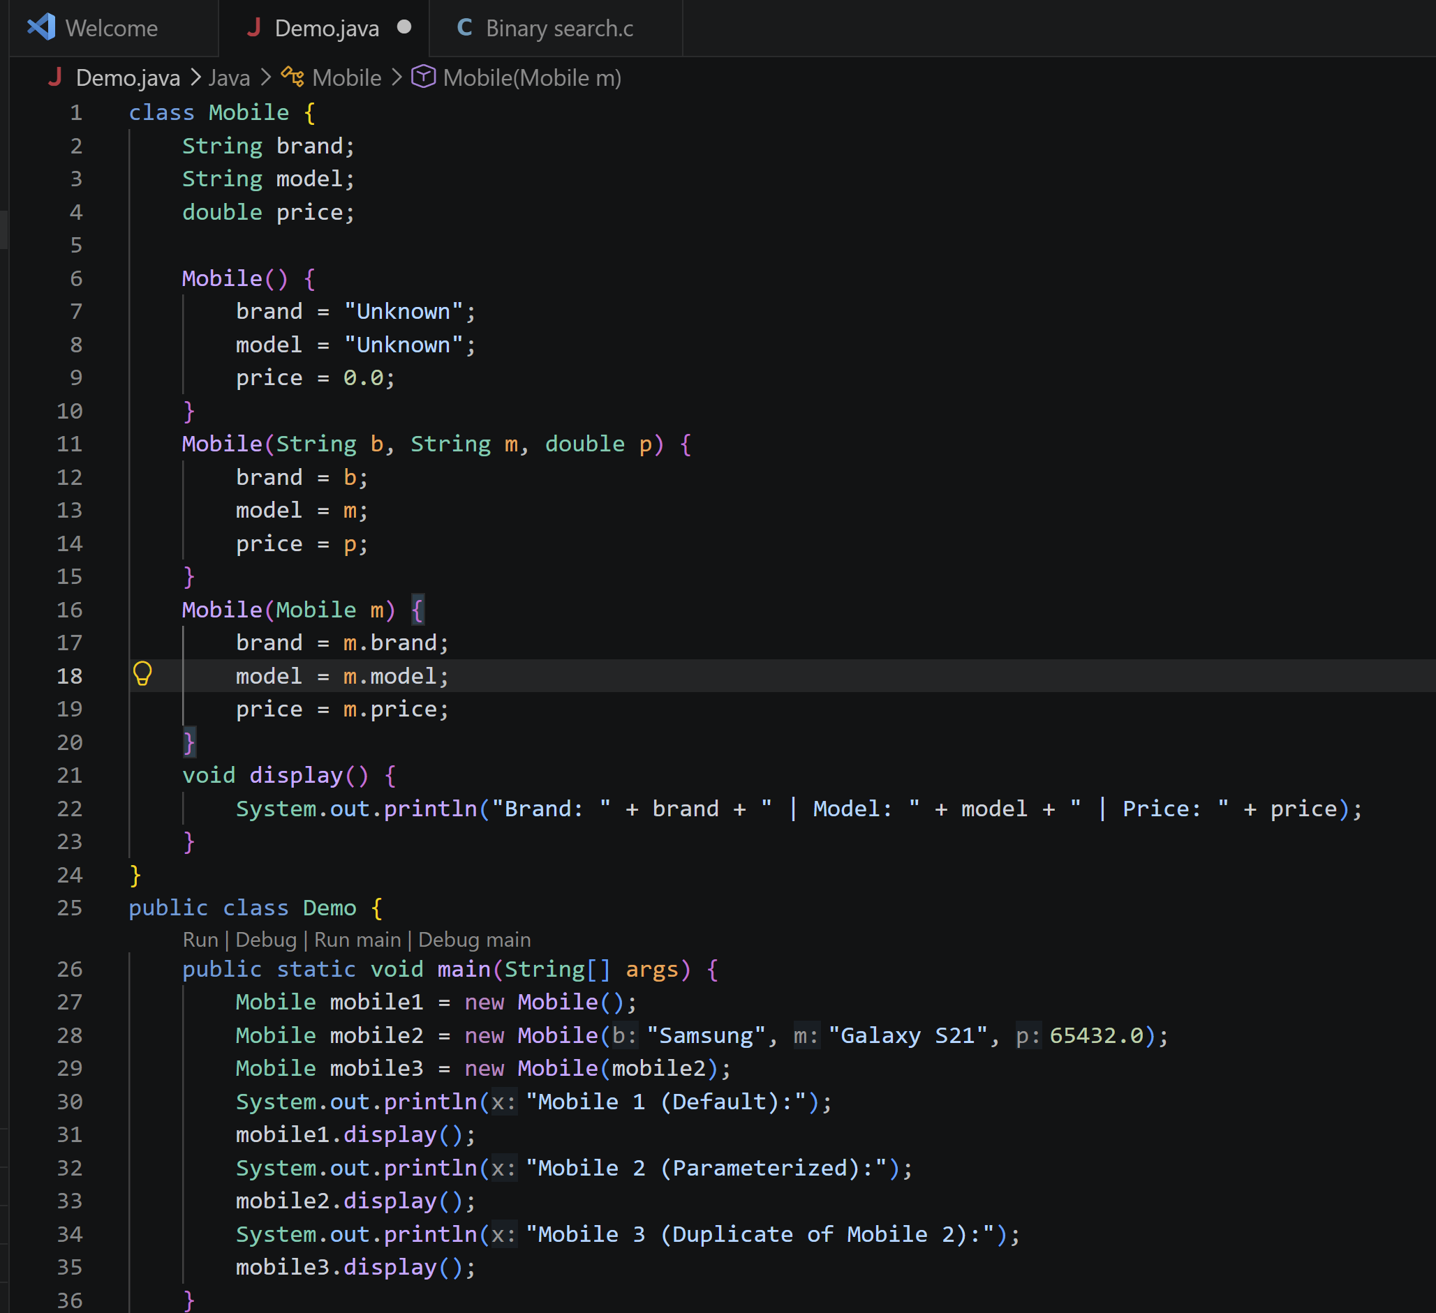

Output:

